Deploy Static Website on AWS

1. 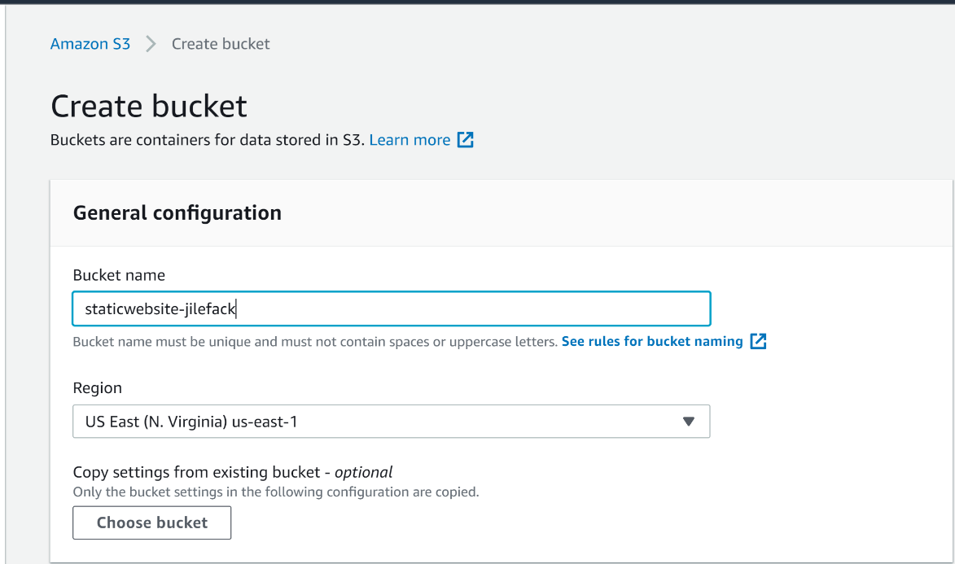Create an s3 bucket called staticwebsite-jilefack

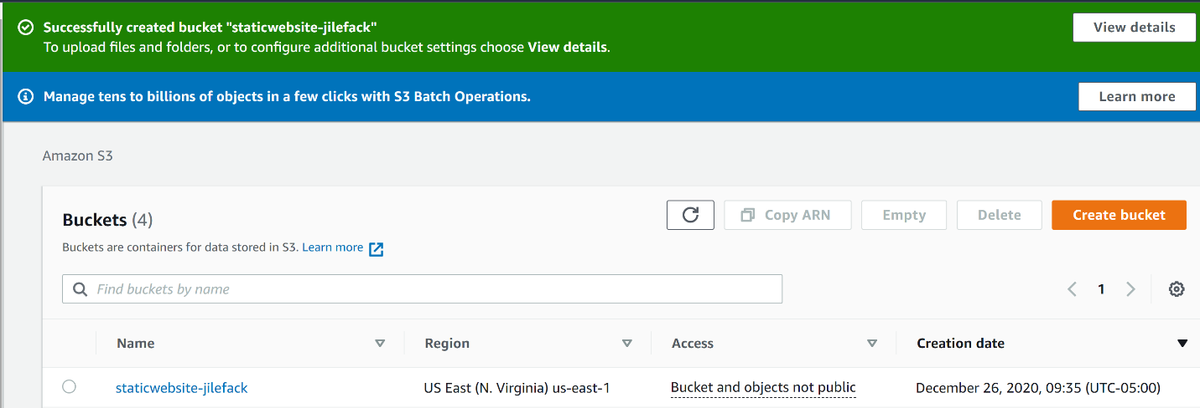

1. configure the bucket for website hosting, and secure it using IAM policies
   1. 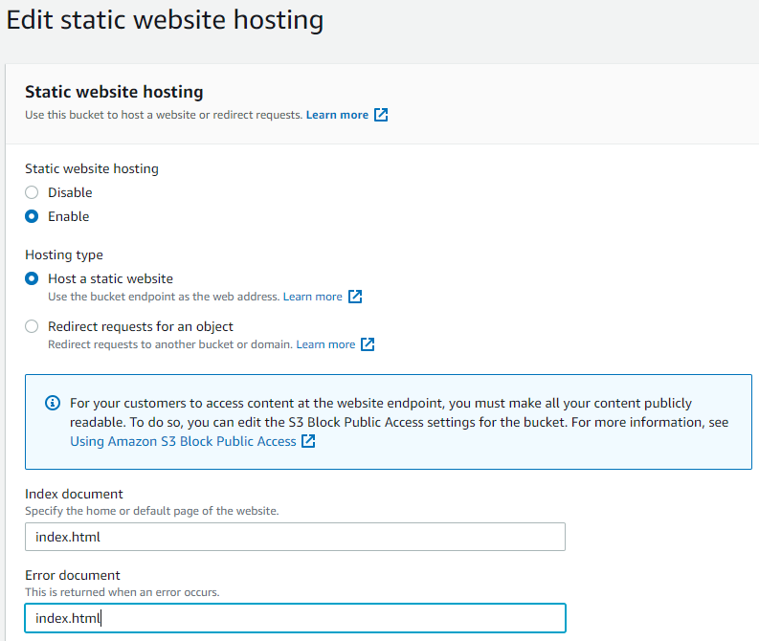Static website hosting configuration
   2. 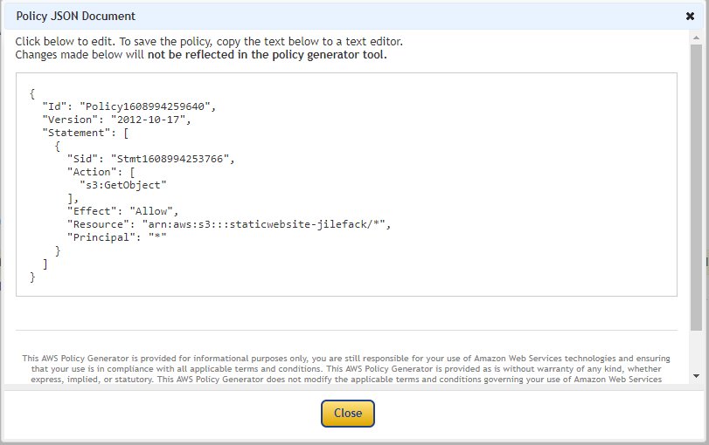Secure s3 bucket using IAM policies

{

“Id”: “Policy1608994259640”,

“Version”: “2012-10-17”,

“Statement”: [

{

“Sid”: “Stmt1608994253766”,

“Action”: [

“s3:GetObject”

],

“Effect”: “Allow”,

“Resource”: “arn:aws:s3:::staticwebsite-jilefack/\*”,

“Principal”: “\*”

}

]

}

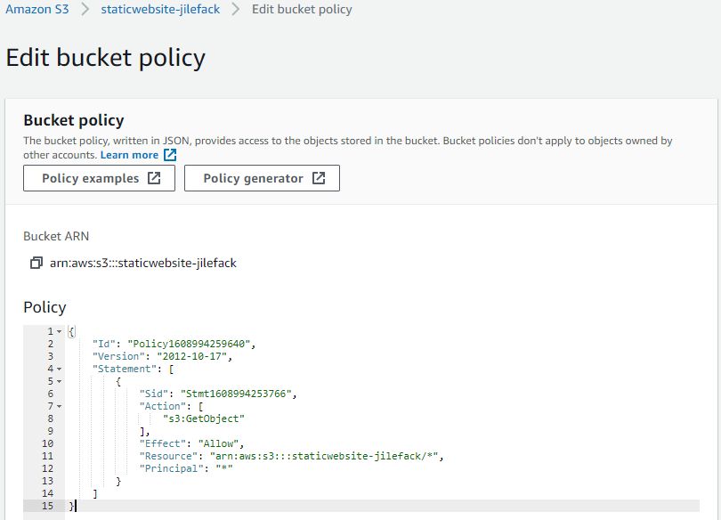

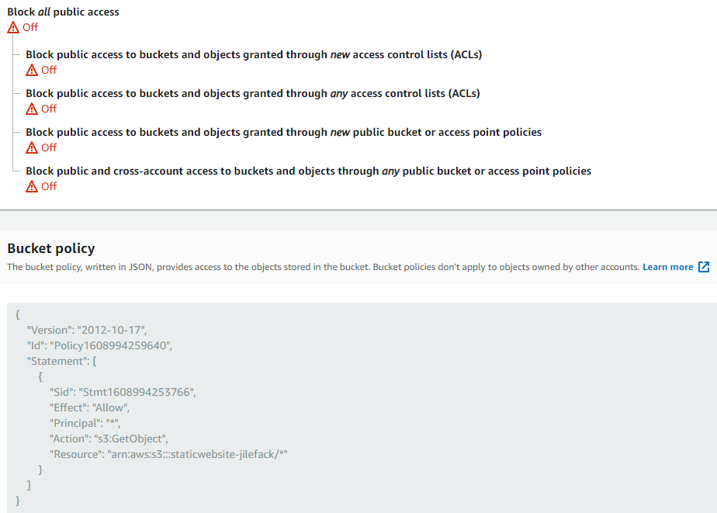

1. Upload the website files to the s3 bucket and speed up content delivery using AWS’s content distribution network service, CloudFront
   1. upload the website files to the s3 bucket (staticwebsite-jilefack)

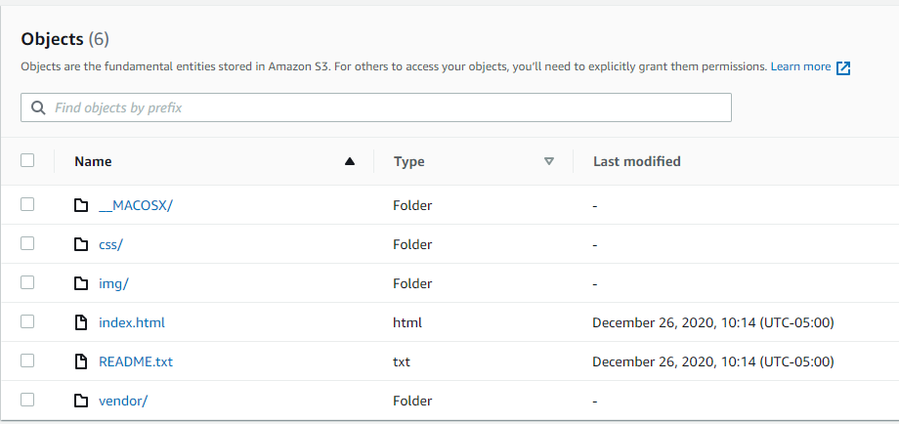

* 1. speed up content delivery using AWS’s content distribution network service, CloudFront

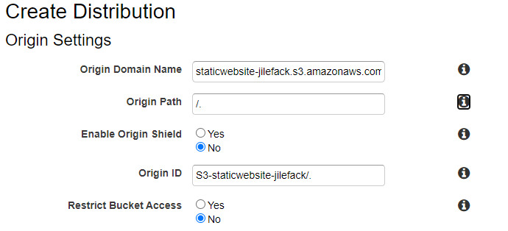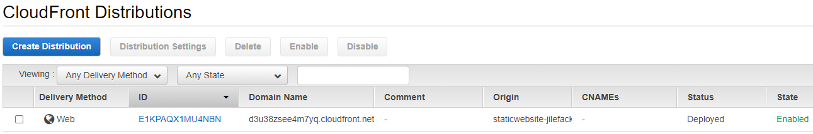

d3u38zsee4m7yq.cloudfront.net/index.html

